Experiment 19: Edge Detection using Sobel Matrix along XY axis (Combined)
Software / Tools: Python · OpenCV (cv2)

AIM
To detect edges in both X and Y directions and combine them to get the overall edge magnitude using the Sobel operator.
ALGORITHM
1. Import OpenCV.
2. Read the image and convert it to grayscale.
3. Compute the Sobel gradient along the X axis (dx=1, dy=0).
4. Compute the Sobel gradient along the Y axis (dx=0, dy=1).
5. Combine both gradients using cv2.magnitude() to get the overall edge strength.
6. Convert the result to 8-bit using cv2.convertScaleAbs().
7. Display and save the combined Sobel-XY edge image.
PROGRAM (SOURCE CODE)
import cv2

img = cv2.imread("image.jpg")
gray = cv2.cvtColor(img, cv2.COLOR_BGR2GRAY)

sobel_x = cv2.Sobel(gray, cv2.CV_64F, 1, 0, ksize=3)
sobel_y = cv2.Sobel(gray, cv2.CV_64F, 0, 1, ksize=3)

# Combine both directions
sobel_xy = cv2.magnitude(sobel_x, sobel_y)
sobel_xy = cv2.convertScaleAbs(sobel_xy)

cv2.imshow("Sobel XY (Combined)", sobel_xy)
cv2.waitKey(0)
cv2.destroyAllWindows()

OUTPUT
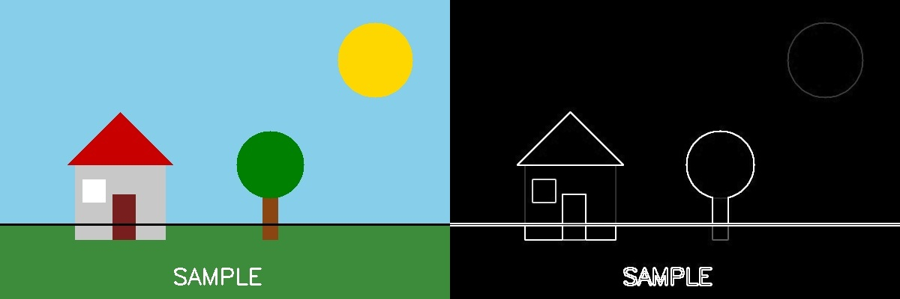
Fig. 19 — Output of Experiment 19: Edge Detection using Sobel Matrix along XY axis (Combined).
RESULT
Detect edges in both X and Y directions and combine them to get the overall edge magnitude using the Sobel operator — completed successfully, as demonstrated in the output shown above.

